**Introduction**

“DEPARTMENT OF BCA & BCS MANAGEMENT SYSTEM” is the management system which refers to BCA & BCS department. This project is for many purposes because I want to give full satisfaction of the user. This system is aimed to develop the management process.

We can add new staff and students etc. and also retrieve these records afterwards.

This system maintains student report. It can be use by educational institutes to maintain record of staff and student easily. It gives us the complete information about the department.

It has user friendly and modular approach. Data storing is easier.

SCOPE OF PROJECT

* The scope of project “*Department of BCA & BCS management system*” is to support for daily update and maintain information of system.
* In this system we provide facilities such as maintains:-
* Student Entry
* Staff Entry
* Fees Payment Entry
* Student, Staff, Fees payment Reports
* Reports are easily generated

**Existing System**

* Existing system was carried out through manual process.
* Maintenance of the records in the existing system is difficult.
* Lot of time is taken to search for a particular record. There is a chance of occurrence of errors.
* Updating and retrieval of information in this existing system takes more time.
* Thought it has used information system, but it is totally a manual one and hence there is a need of upgrade the system to that of the computer based information system.

***OBJECTIVES***

* **The main objectives of our work are:**
* To provide a proper registration system to the new staff and student.
* To maintain all the account of the student in digital form enrolment up to the end of the study.
* To make the information accessible to the admin in easy way.
* Reduce paper work.
* Generate date wise report to the staff.
* Fast and accurate.

**Proposed System**

* There is need to develop a new system to reduce a human stress & paper work which causes waste of time. The new system should concern the requirements of user are follows:
* *Different operation can generate report easily.*
* *Reduce complexity & increase the speed of project.*
* *System satisfying user requirements & improve efficiency.*
* *Provide accuracy in any operation.*
* It is difficult to achieve this goal using a manual system as the information is redundant, can be scattered & collecting relevant information may be very time consuming.
* It focuses on presenting information in an easy & intelligible manner which provides facilities like student & staff registration and profile creation of students thus reducing paper work and automating the record generation process in an educational institution.

**HARDWARE AND SOFTWARE SPECIFICATION**

* **SOFTWARE REQUIREMENT:**
* **Operating system:** Windows XP/7/8/10.
* **Front end:** Visual Basic 6.0.
* **Back end:** MS ACCESS 2007.
* **HARDWARE REQUIREMENT:**
* **Processor:** Intel ® Dual Core or above.
* **Primary memory(RAM):** 512 MB or above.
* **Secondary memory(ROM):** 32 GB or above.

**FEASIBILITY STUDY**

**Feasibility study:**

After doing the project “Department of BCA & BCS management system”, study and analysing all the existing or required functionalities of the system, the next task is to do the feasibility study for the project. All the project are feasible-given unlimited resources and infinite time.

Feasibility study include consideration od all the possible ways to provide solution to the given problem. The proposed solution should satisfy all the user requirement and should be flexible enough so that future changes can be easily done based on the future upcoming requirements.

1. **Economical Feasibility**

This is very important aspects to be considered while developing the project. We decided the technology based on minimum possible cost factor

* All hardware and software cost has to be born by the organization
* Overall we have estimated that the benefit the organization is going to receive from the proposed system will surely overcome the initial cost and the later on running cost for the system.

1. **Technical Feasibility**

This included the study of function, performance and constraints that may affects the ability to achieve acceptable system. For this feasibility study, we studied complete functionality to be provide in the system, and checked if everything was possible us in different type of frontend and backend platforms.

1. **Self Feasibility**

The aspects of study is to checked the level of acceptance of the system by the people. This include the process of training the people to use the system efficiently. The people must not feel threatened by the system, instead must accept as necessity.

**FACT FINDING TECHNIQUES**

* Fact-finding is an important activity in system investigation. In this stage, the functioning of the system is to be understood by the system analyst to design the proposed system.
* Various methods are used for this and these are known as fact- finding techniques. The analyst needs to fully understand the current system.
* The analyst needs data about the requirements and demands of the project undertaken and the techniques employed to gather this data are known as fact-finding techniques.
* Various kinds of techniques are used and the most popular among them the personal observations made by the analyst himself.

Has

Course

Paid

By

Fee

Generate

Report

Manage

Admin

Enquiry

to

Teaches

Has

Department

1

M

Student

1 M M 1 1

1 M

1

Staff

M M

M

M

Learned

by

1

M 1

M M

***Data Flow Diagram:***

1. A data flow (DFD) is a graphical system model that shows all of the main requirements for an information system in one data diagram: Inputs and outputs processes, and data storage.
2. A DFD describes what data flows rather than how it is processed.
3. Everyone working on a development project can see all aspects of the system working together at once with DFD.  That is one reason for its popularity.
4. The DFD is also easy to read because it is graphical model.
5. The DFD is mainly used during problem analysis. End Users, management, and all information systems workers typically can read and interpret the DFD with minimal training

***DFD SYMBOLS:***

* Process -:

* Data Flow -:
* External entity -:

* Data source -:

Enquiry for

Student

Staff

Course details

Department

Management

Course details Student

Select Course

Paid fees

Account of student

Queries

Staff details

Course details All Report

Select course

Student

Student details Update Student Data

Staff Details Update Staff Data

Staff

Management

User/Password details Update Login

Student

Student details update Student Data

Management

Course detail update Course Data

Staff

Staff details update Staff Data

Paid Fees

Student

Get Receipt Update Fees Data

Fee

Fee details

Management

Refer Student

Daily updates

Refer Staff

Queries

Refer Course

Monthly Uses Report

Refer Fee

**STUDENTS ENTRY**

|  |  |  |  |  |
| --- | --- | --- | --- | --- |
| Field No. | Attributes | Data Type | Size | Description |
| 1 | Student_RollNo | Number | 05 | Students Roll No. |
| 2 | Student_name | Text | 20 | Students Name |
| 3 | Student_DOB | Date/Time | 10 | Students Date of Birth |
| 4 | Student_gender | Text | 06 | Students gender |
| 5 | Department | Text | 15 | Students department |
| 6 | Year | Text | 15 | Students year |
| 7 | Student_address | Text | 40 | Students address |
| 8 | Student_PhoneNo. | Number | 10 | Students phone no. |

**STAFF ENTRY**

|  |  |  |  |  |
| --- | --- | --- | --- | --- |
| Field No. | Attributes | Data Type | Size | Description |
| 1 | Staff_ID | Number | 05 | ID |
| 2 | Staff_name | Text | 20 | Name |
| 3 | Staff_gender | Text | 06 | Gender |
| 4 | Course | Text | 15 | Course |
| 5 | Subject | Text | 15 | Subject |
| 6 | Staff_email | Text | 20 | Email |
| 7 | AadharNo. | Number | 15 | Aadhar no. |
| 8 | Staff_address | Text | 40 | Address |
| 9 | Staff_phoneNo | number | 10 | Phone no. |

**FEES PAYMENT ENTRY**

|  |  |  |  |  |
| --- | --- | --- | --- | --- |
| Field | Attribute | Data type | Size | Description |
| 1 | Student_rollno | Number | 05 | Roll no |
| 2 | Student_name | Text | 20 | Name |
| 3 | Student_course | Text | 15 | Course |
| 4 | Student_year | Text | 15 | Year |
| 5 | Date | Date/time | 10 | Date |
| 6 | Student_type | Text | 09 | Type |
| 7 | Total | Number | 05 | Total fees |
| 8 | Paidfees | Number | 05 | Paid fees |
| 9 | pending | Number | 05 | Pending fees |

*Login Form:*

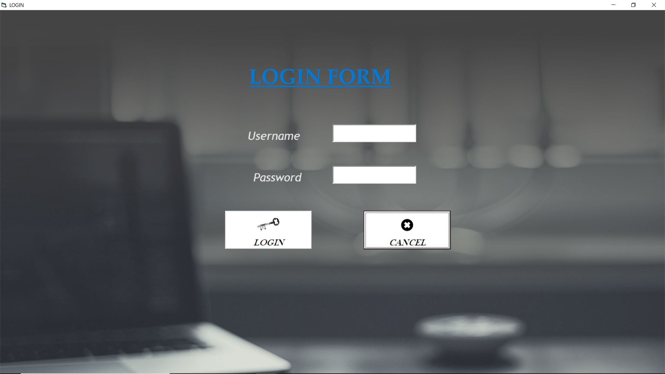

*Login Process:*

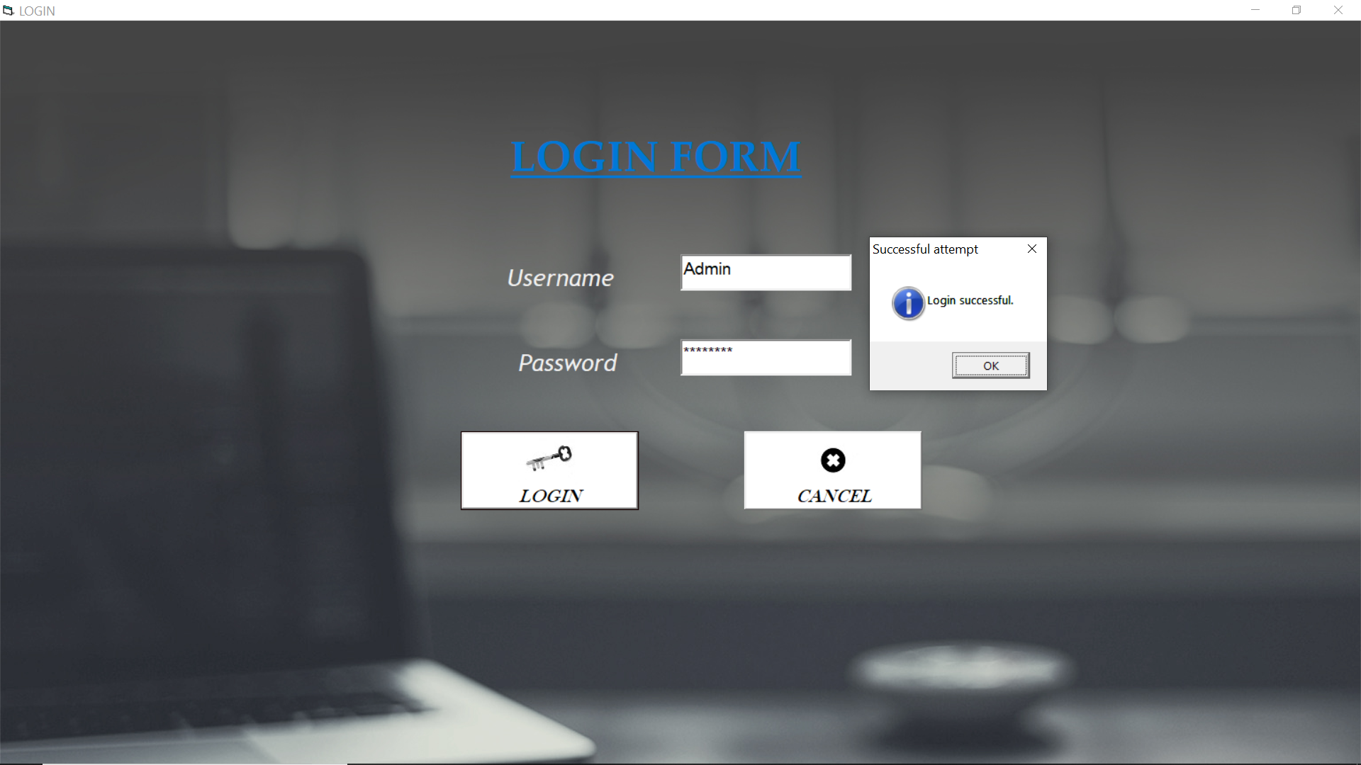

*MDI Form:*

**

*Admission Form:*

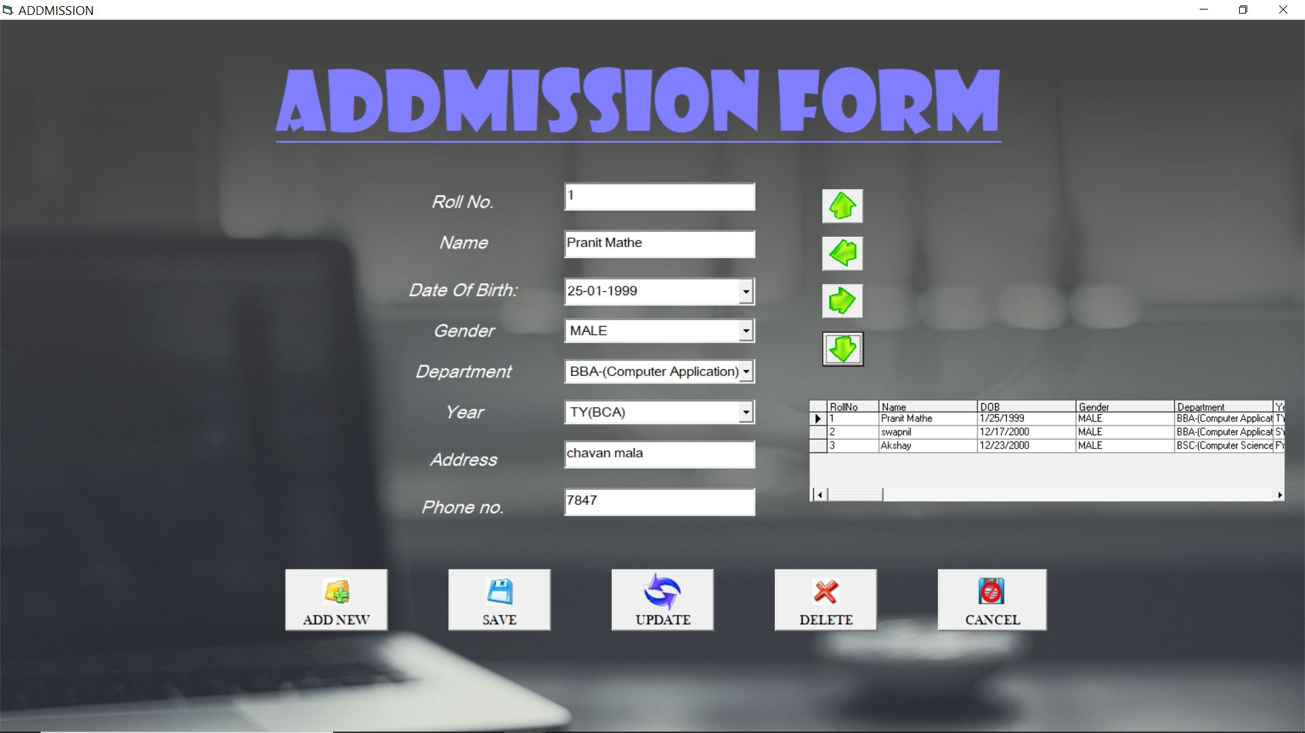

*Add New process:*

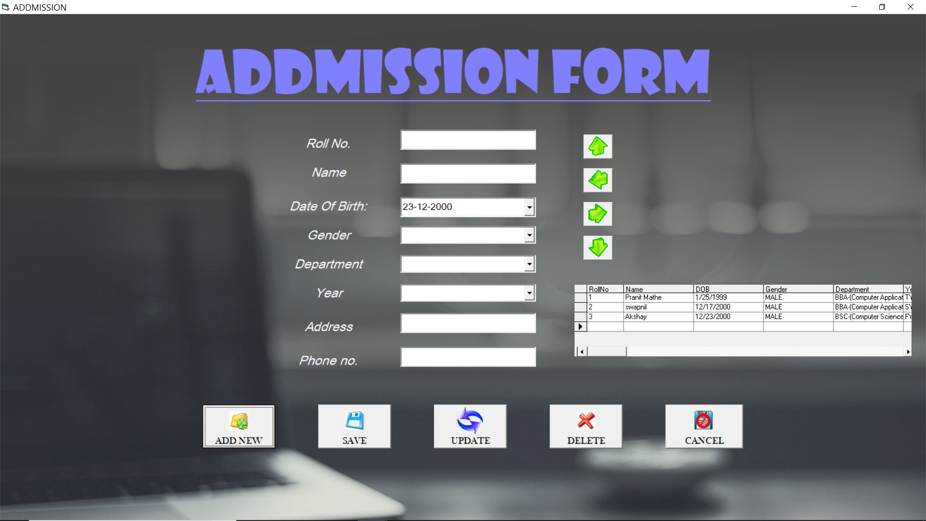

*Save process:*

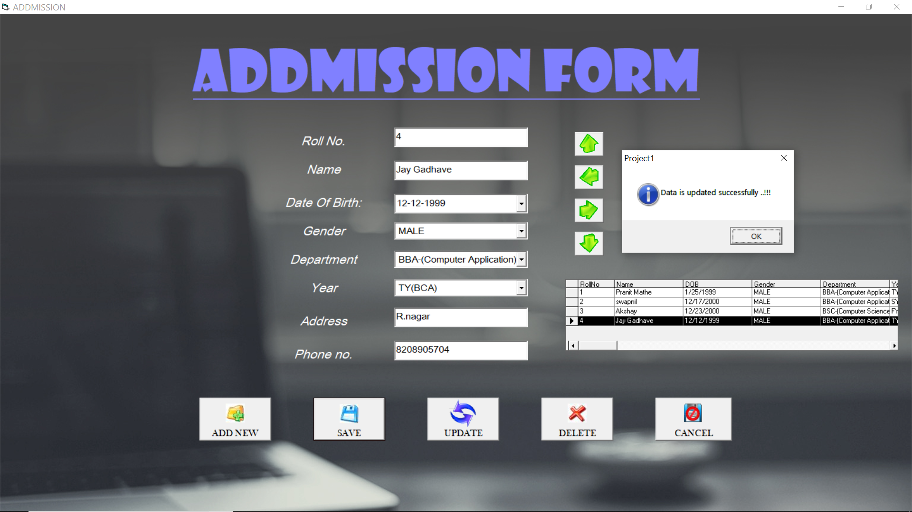

*Delete process: Confirmation*

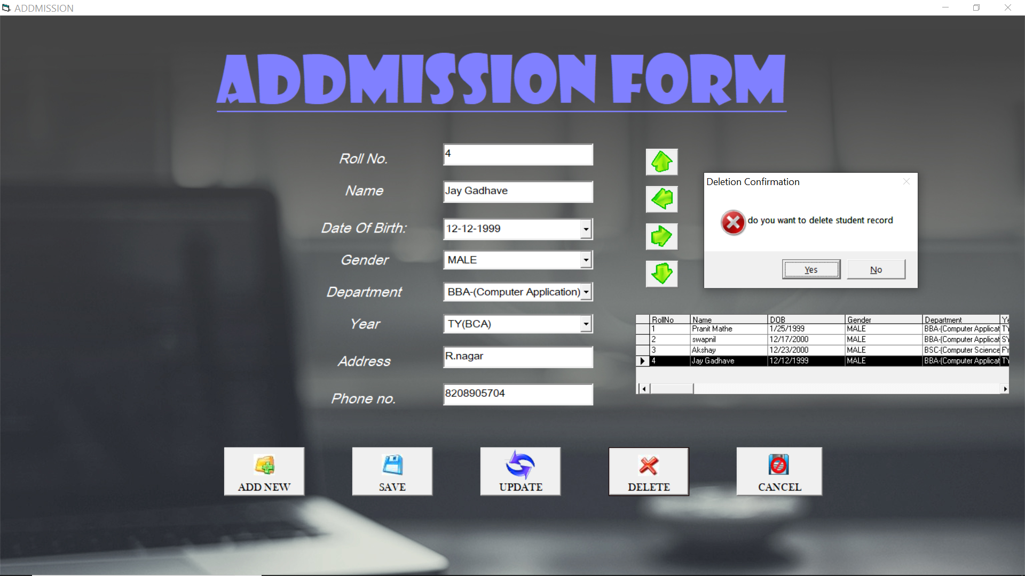

*Delete process: Successful*

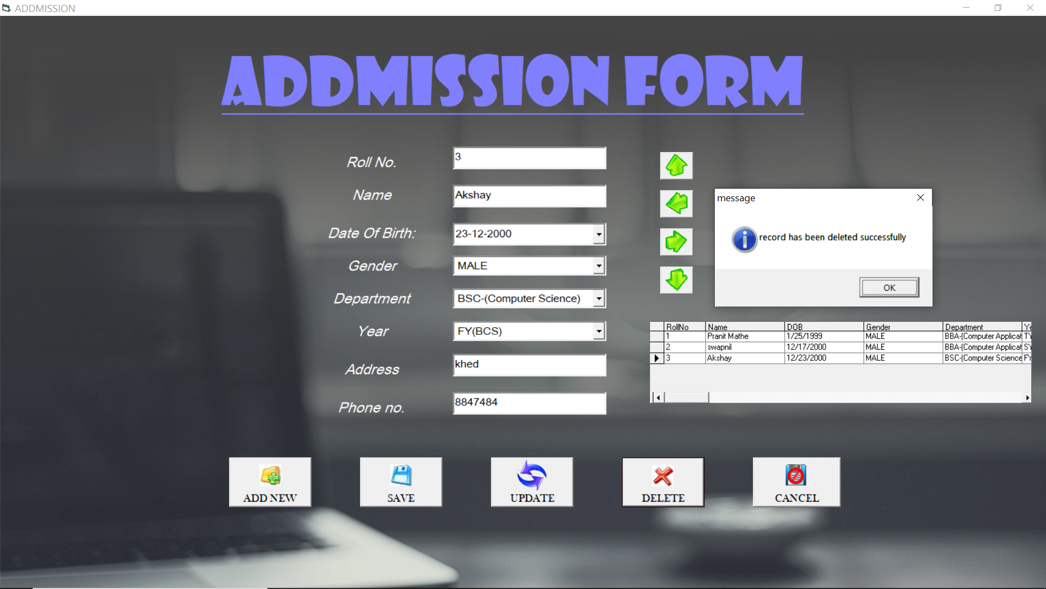

*Update Process:*

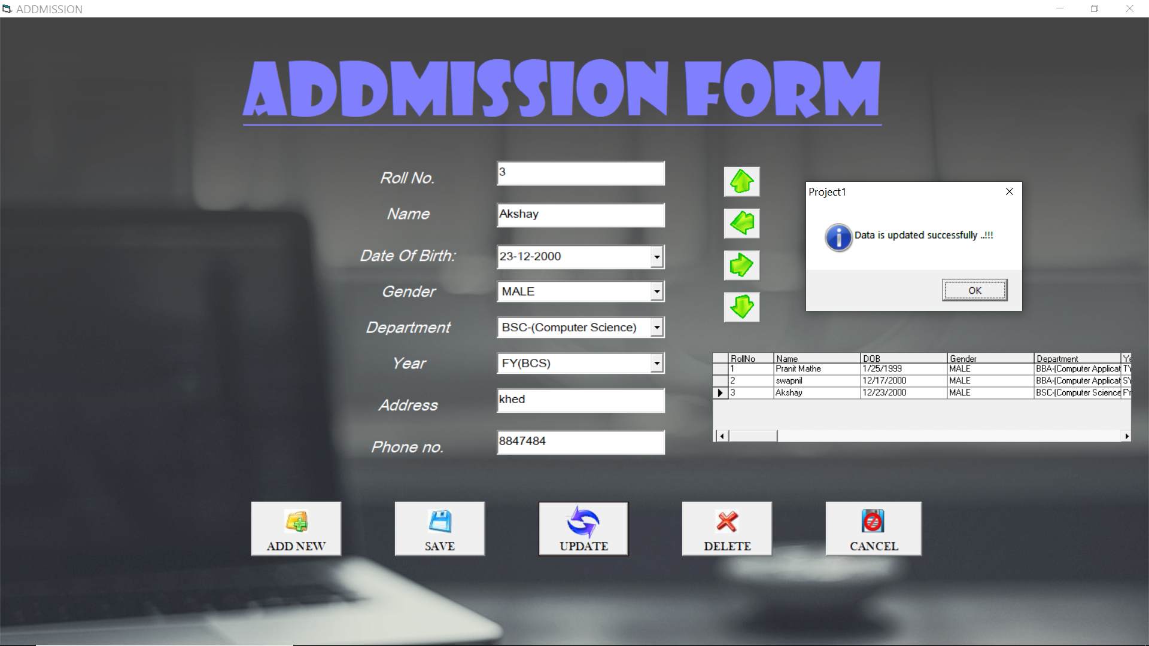

*Staff Form:*

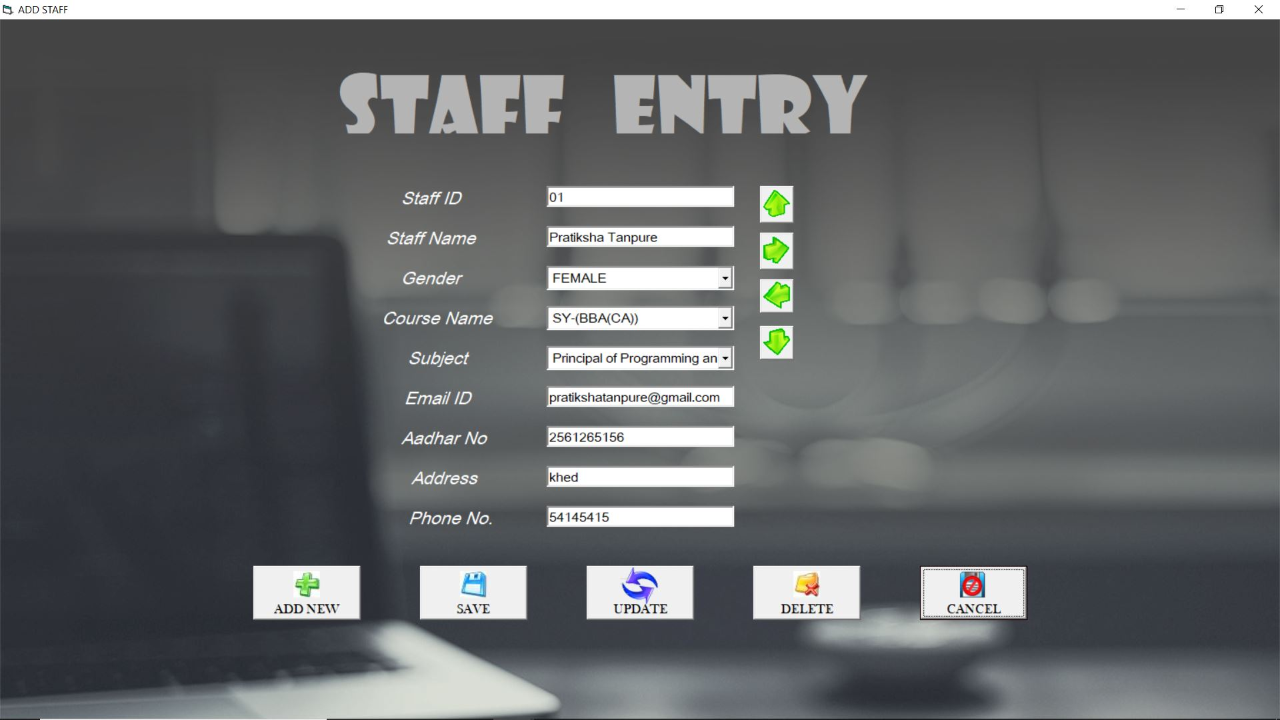

*Add new Process:*

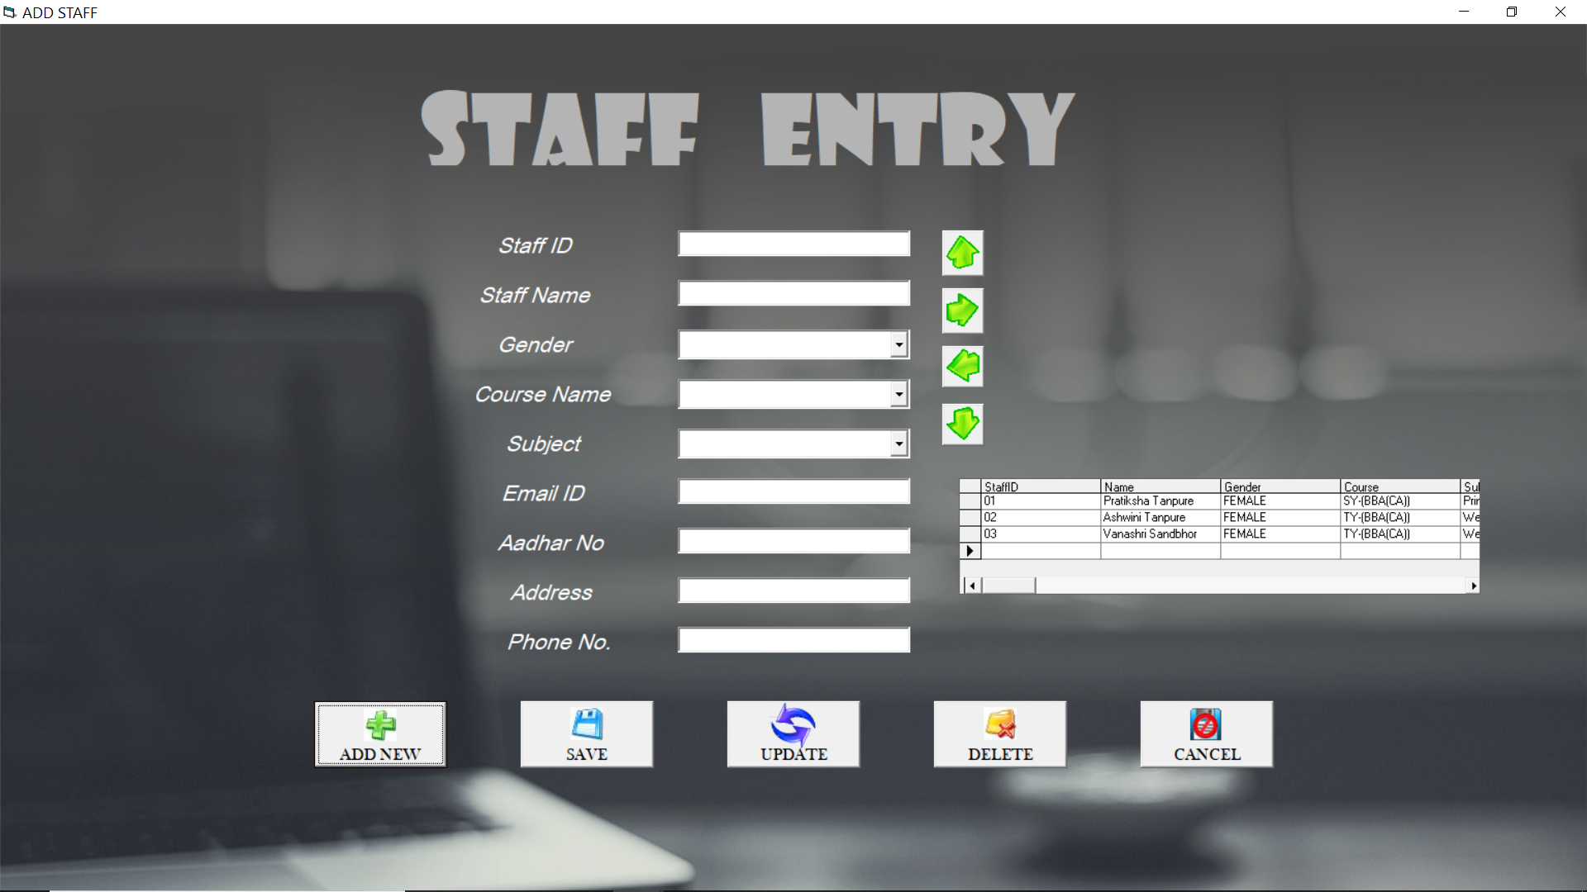

*Save Process:*

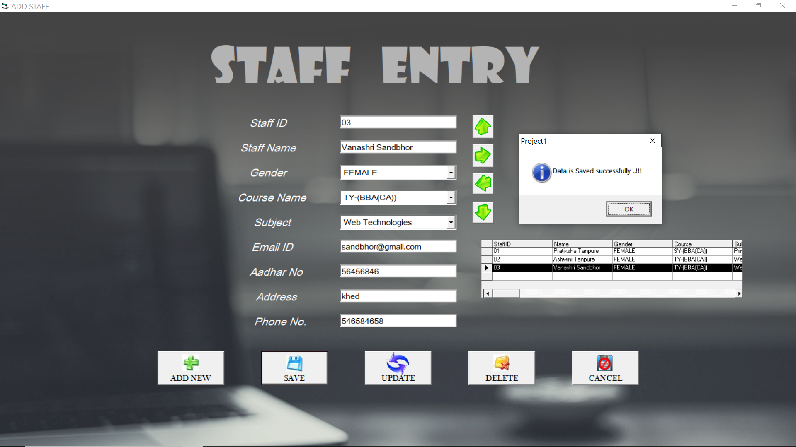

*Update process:*

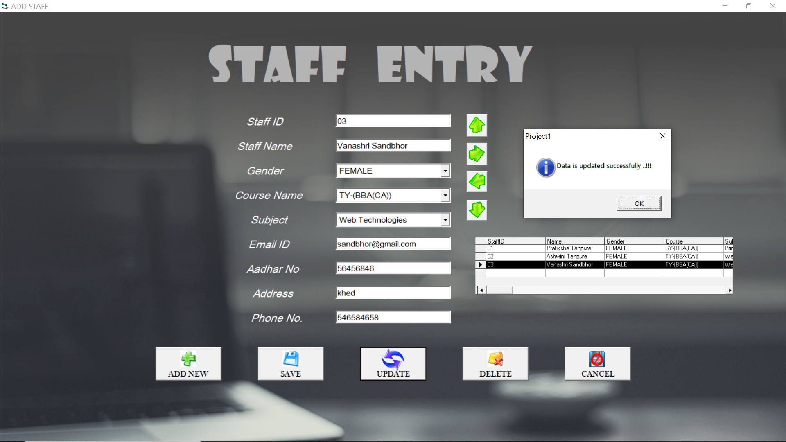

*Delete process: Confirmation*



*Delete process: Successful*

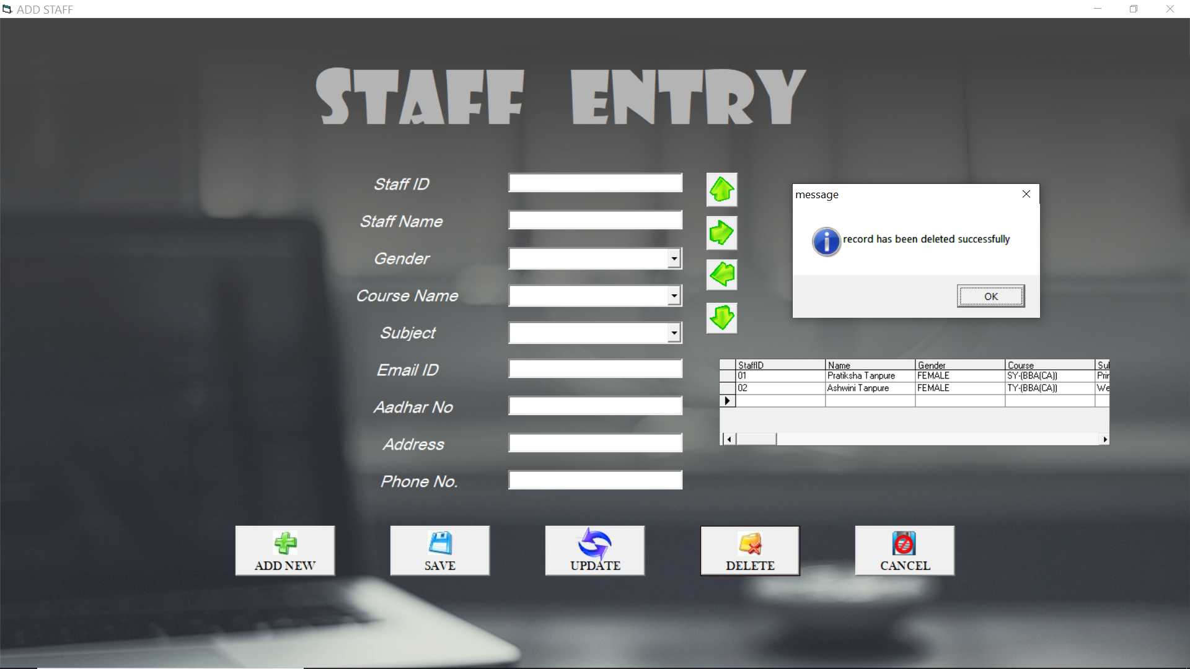

*BCA Fees Payment Form:*

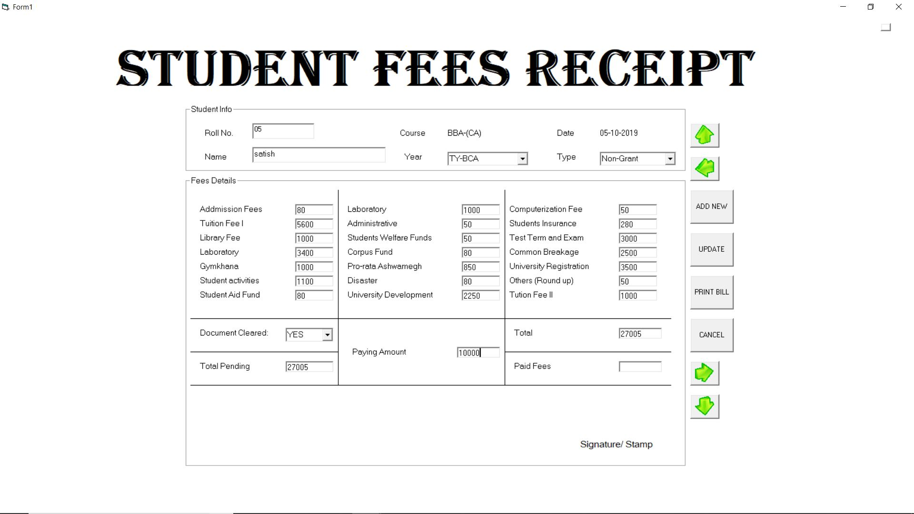

*Billing Form:*

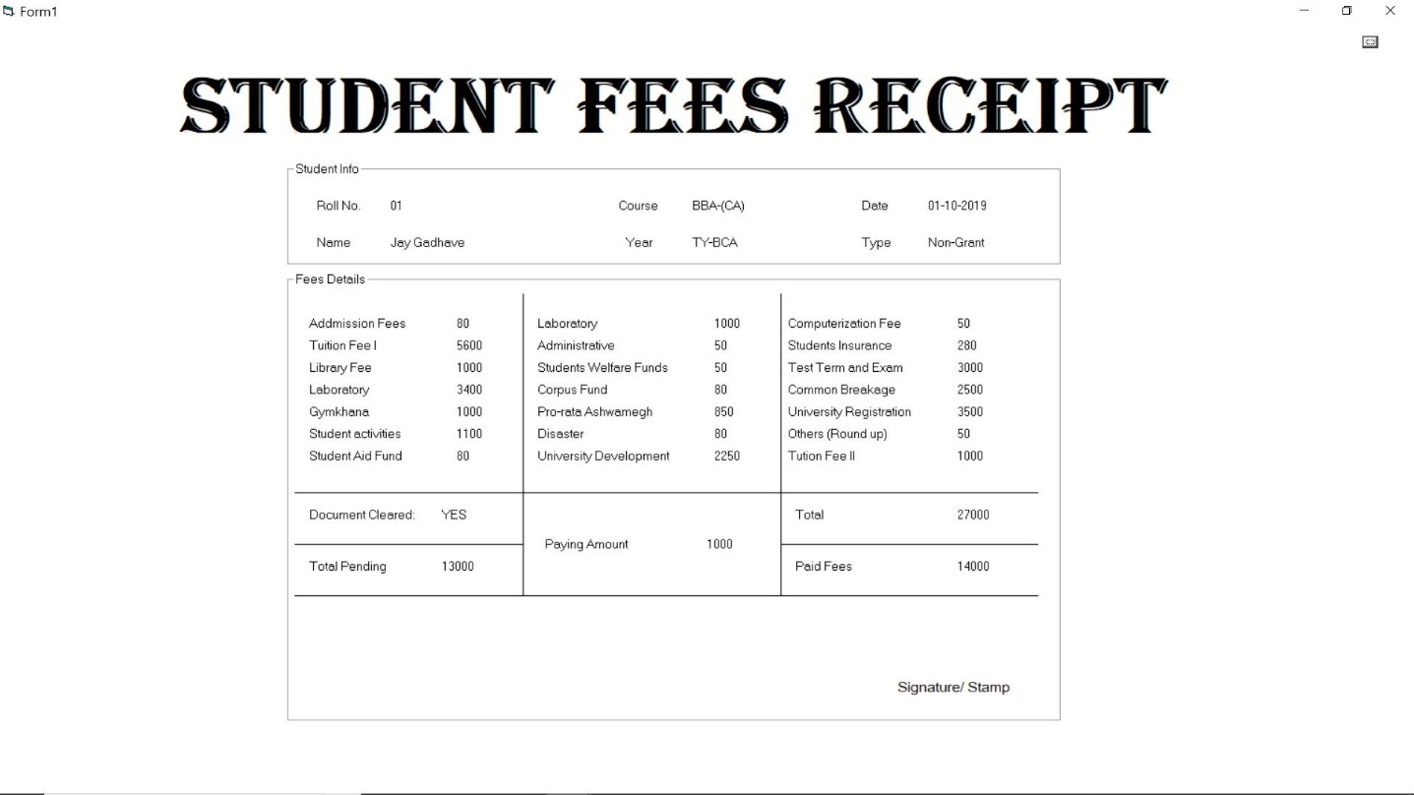

*BCS Fees Payment Form:*

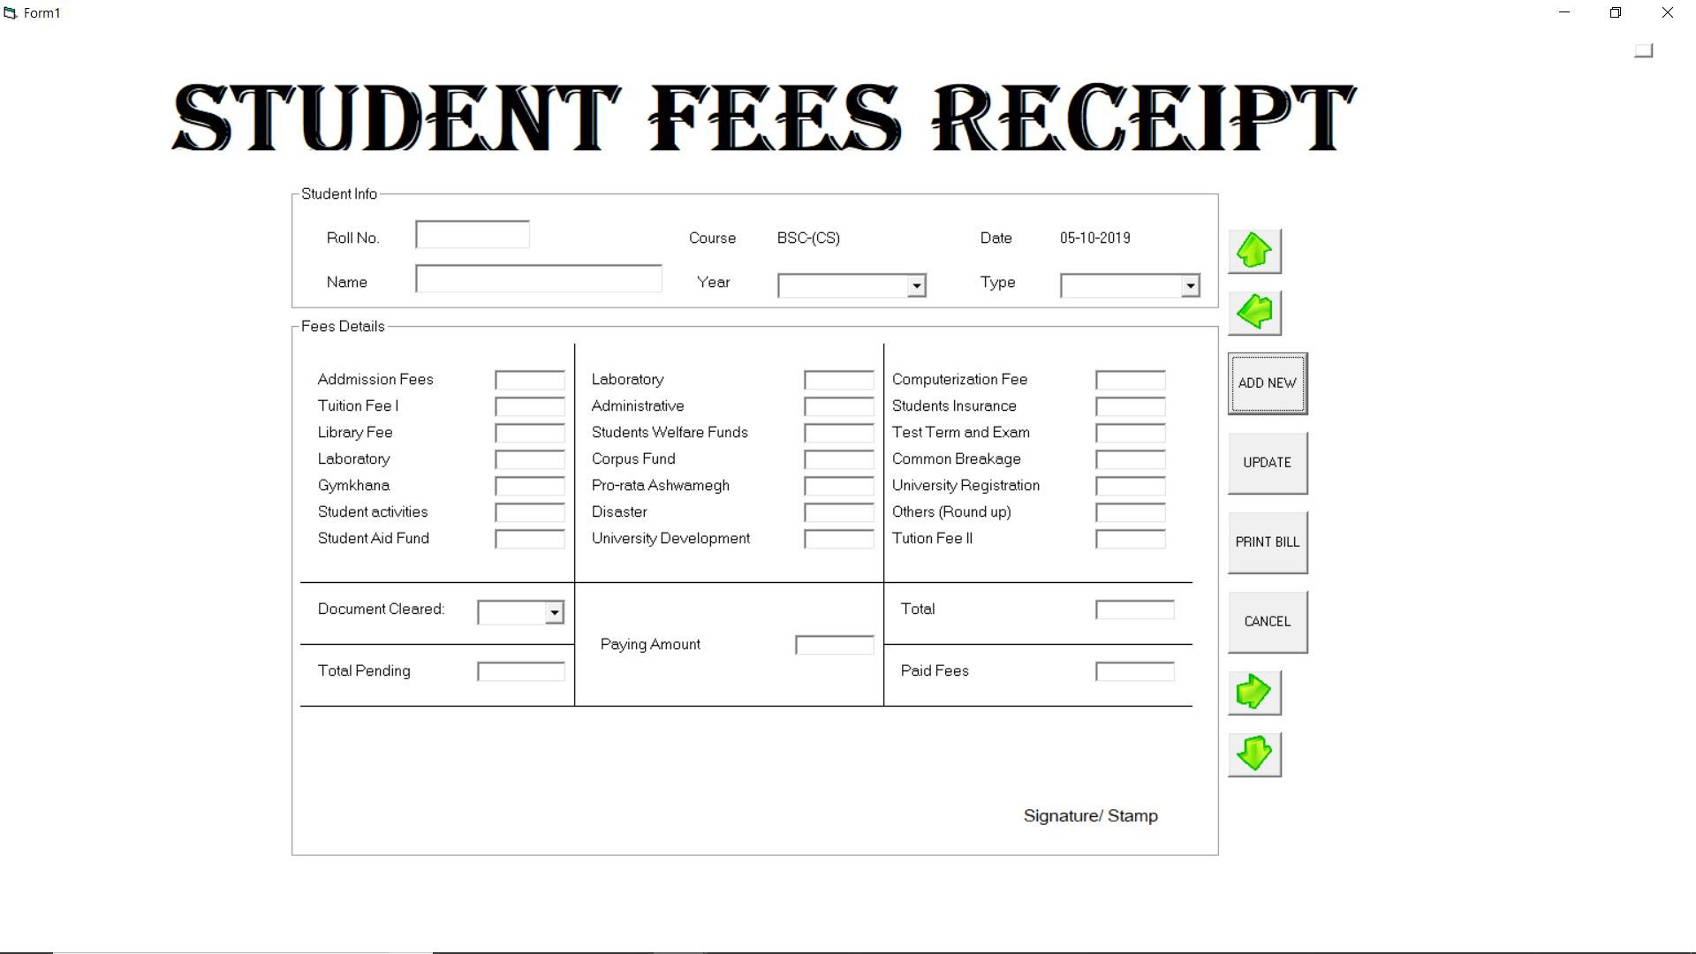

*Billing Form:*

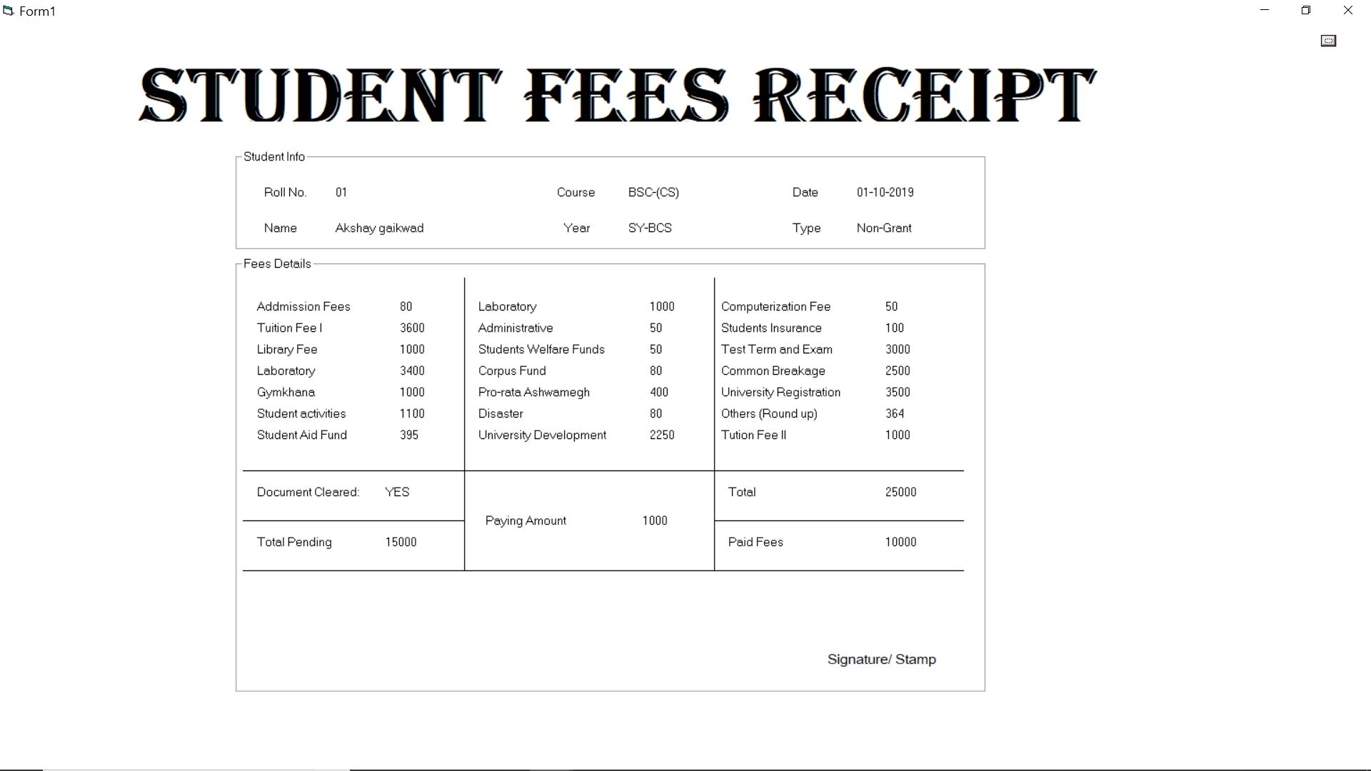

*Report Form:*

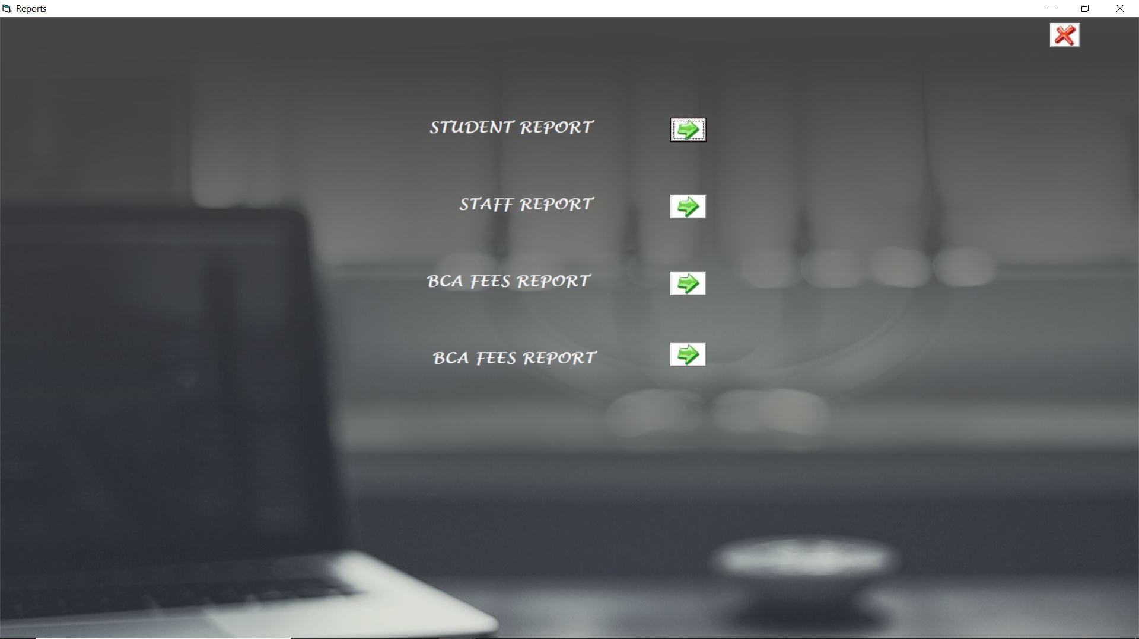

*Student Report:*

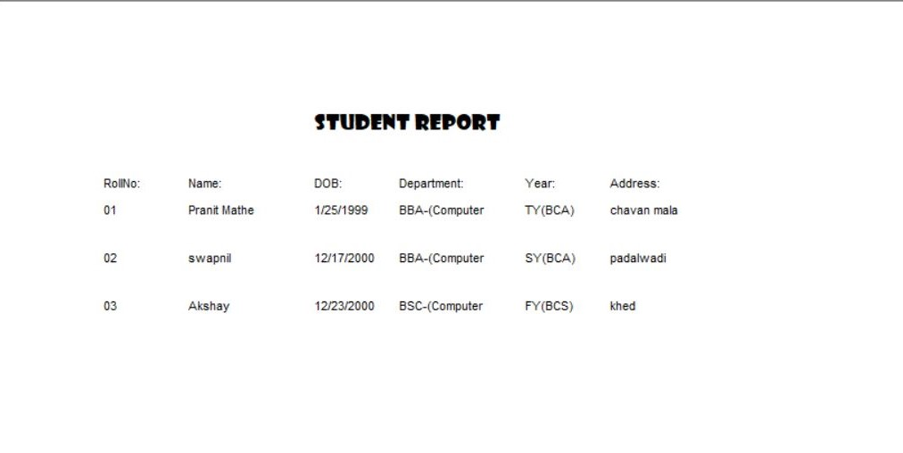

*Staff Report:*

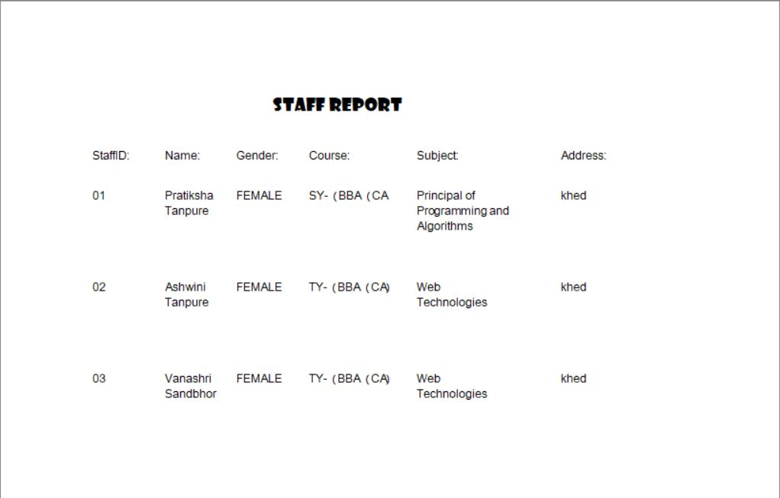

*BCA Fees Report:*

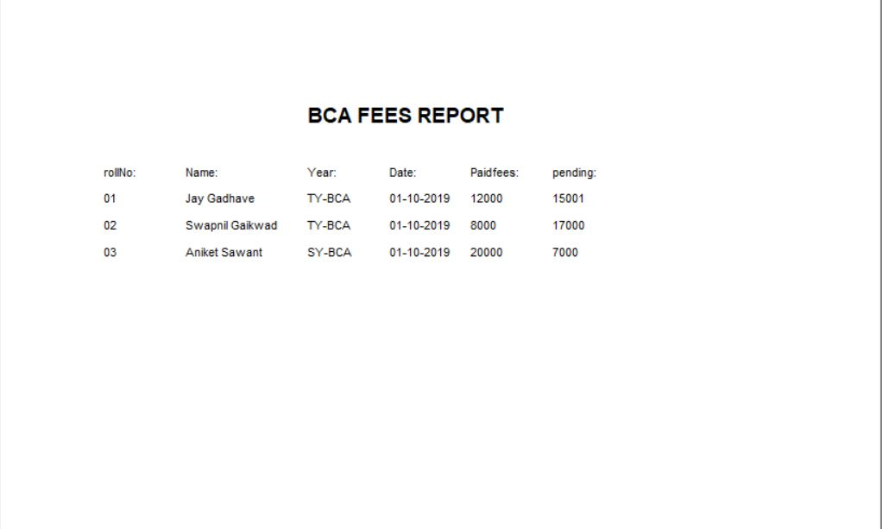

*BCS Fees Report:*

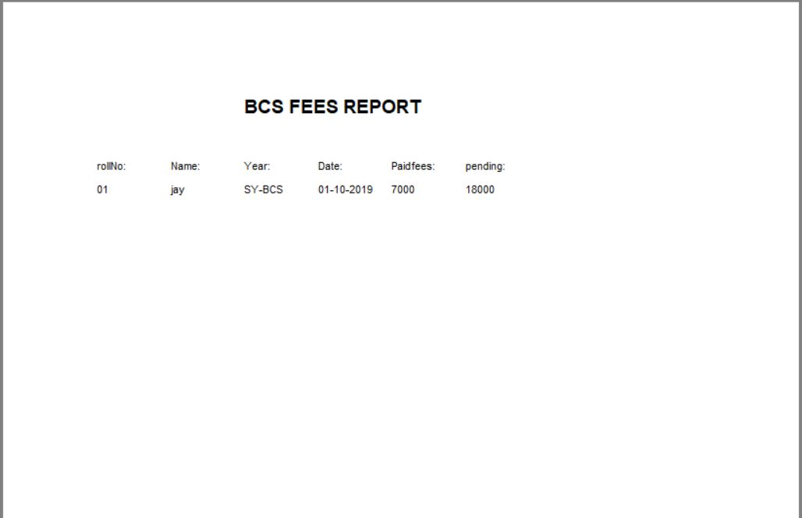

Advantages

* Dedicated Professional staff for each subject.
* Time saving along with high quality services.
* Smooth and timely execution of reports.
* This department can also provide the receipt for every student fee payment.
* The records like admission, fees payment and staff details also retrieve afterwards.

**Future Enhancement**

* At a later point of time we plan to enhance our software.
* The following points would be given emphasis on:
* The facility of Online registration.
* The facilities such as Head of Department (HOD)would also be provided.
* The facilities such as Multiple Branches Handle by one System at a time.
* The record of present students per subject lecture also be provided.
* We will also provide some entrance exam for new admission for freshers.

***Bibliography***

* ***Websites:*** 
  + <http://www.google.com>
  + <http://www.docs.microsoft.com/vb/languages>

​​

* ***Books:***
* Microsoft Visual Basic 6.0
  + - Nirali Publication
* Software Engineering
  + - Vision Publication